Day 3: Network Discovery and Inventory

Objective:
The objective of this lab is to perform network discovery using Nmap on a target machine running Metasploitable2. The goal is to identify all open ports, running services, and their versions to create a complete network inventory.

Step 1: Running the Nmap Scan
First, we launched Kali Linux and opened the terminal. We ran the following Nmap command to perform a service version scan on the target IP address.

Command Used:
nmap -sV 192.168.56.102

[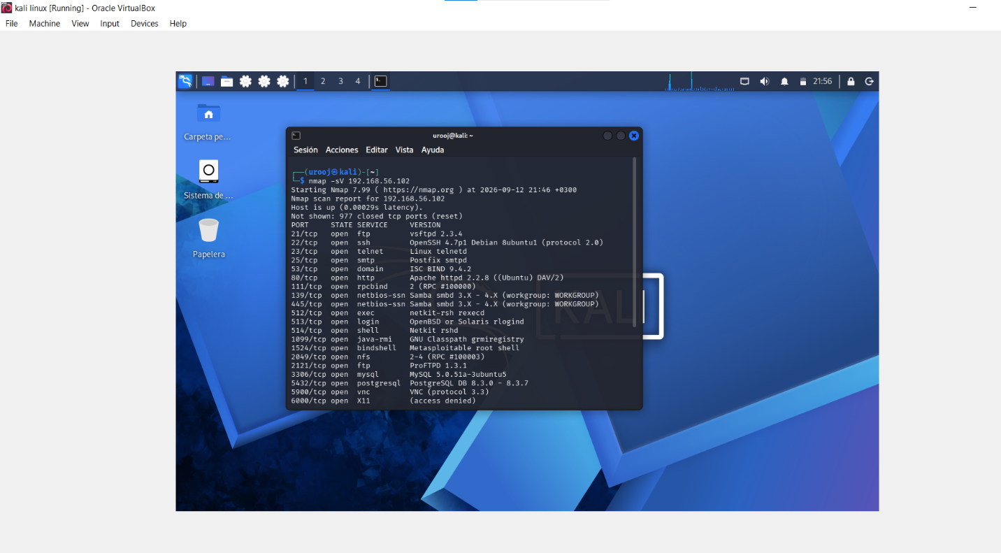]
Figure 1: Executing nmap -sV 192.168.56.102 on Kali Linux

Step 2: Scan Results
After waiting for 2-3 minutes, the scan was completed. The results showed multiple open ports and services running on the Metasploitable2 machine.

[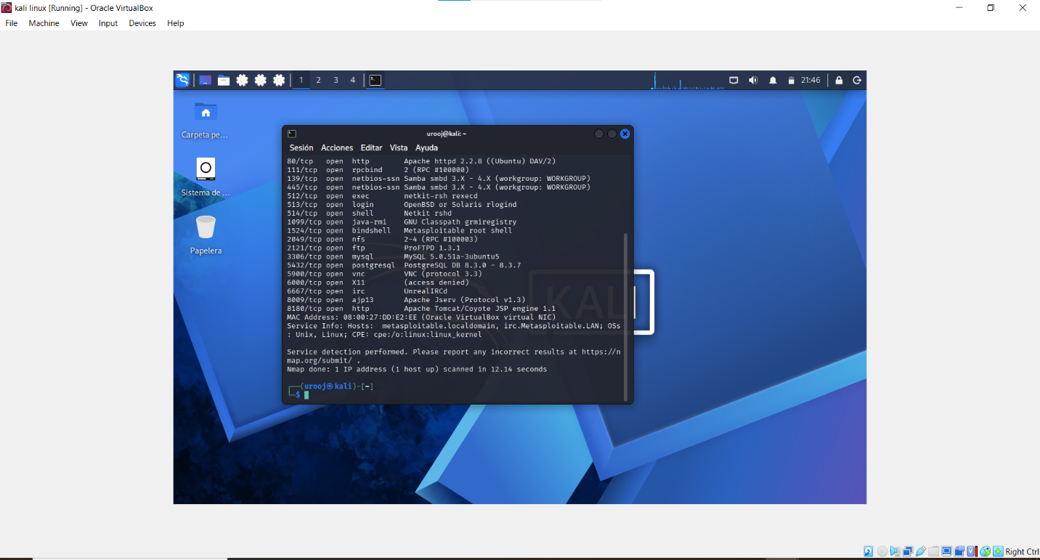]
Figure 2: Nmap Scan Results for 192.168.56.102

Step 3: Network Inventory Table
Based on the scan results, we created a network inventory table to document all discovered services.

Table 1: Network Inventory of 192.168.56.102

| IP Address | Port | Service | Version |
| --------------- | ----- | ------------ | ----------------------------------------- |
| 192.168.56.102 | 21 | ftp | ProFTPD 1.3.1 |
| 192.168.56.102 | 22 | ssh | OpenSSH |
| 192.168.56.102 | 23 | telnet | Linux telnetd |
| 192.168.56.102 | 25 | smtp | Postfix |
| 192.168.56.102 | 53 | domain | BIND |
| 192.168.56.102 | 80 | http | Apache httpd 2.2.8 |
| 192.168.56.102 | 111 | rpcbind | 2 (RPC #100000) |
| 192.168.56.102 | 139 | netbios-ssn | Samba smbd 3.X - 4.X |
| 192.168.56.102 | 445 | netbios-ssn | Samba smbd 3.X - 4.X |
| 192.168.56.102 | 512 | exec | netkit-rsh rexecd |
| 192.168.56.102 | 513 | login | OpenBSD or Solaris rlogind |
| 192.168.56.102 | 514 | shell | Netkit rshd |
| 192.168.56.102 | 1099 | java-rmi | GNU Classpath grmiregistry |
| 192.168.56.102 | 1524 | bindshell | Metasploitable root shell |
| 192.168.56.102 | 2049 | nfs | 2-4 (RPC #100003) |
| 192.168.56.102 | 2121 | ftp | ProFTPD 1.3.1 |
| 192.168.56.102 | 3306 | mysql | MySQL 5.0.51a-3ubuntu5 |
| 192.168.56.102 | 5432 | postgresql | PostgreSQL DB 8.3.0 - 8.3.7 |
| 192.168.56.102 | 5900 | vnc | VNC (protocol 3.3) |
| 192.168.56.102 | 6000 | X11 | access denied |
| 192.168.56.102 | 6667 | irc | UnrealIRCd |
| 192.168.56.102 | 8009 | ajp13 | Apache Jserv (Protocol v1.3) |
| 192.168.56.102 | 8180 | http | Apache Tomcat/Coyote JSP engine 1.1 |

Conclusion:
The Nmap scan successfully identified 23 open ports on the Metasploitable2 target machine. The results show that multiple vulnerable services such as FTP, Telnet, Samba, and MySQL are running. This inventory will be used in the next steps for vulnerability assessment and penetration testing.

